Artificial Intelligence (Lab)


Lab-03

Submitted by:
Hafiza Nishwa Jamil

Roll No:
BSSE-4A-S25-046

Submitted to:
Sir Rasikh Ali

Task-01
Graph:
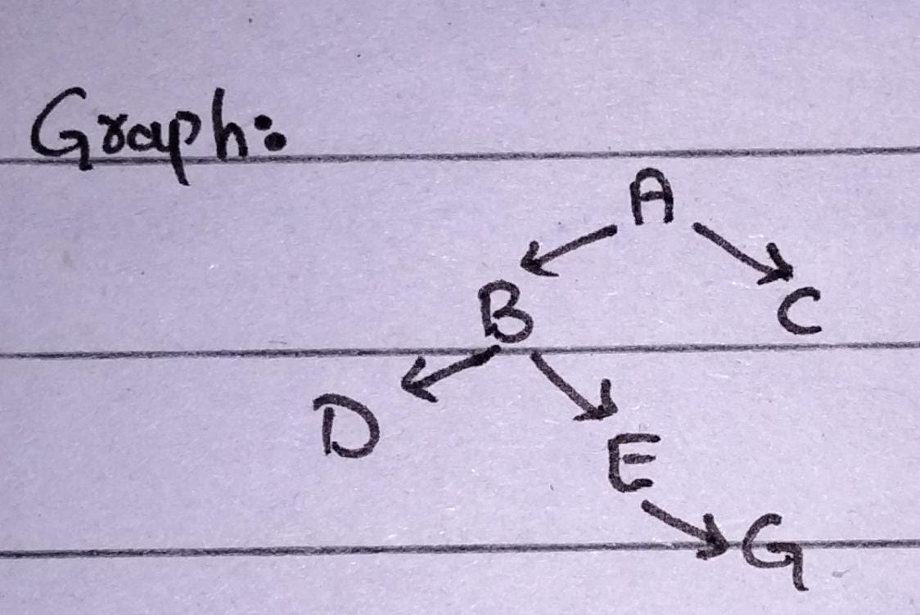
- BFS – Breath First:
BFS checks level by level. It uses Queue.
Queue-Step:
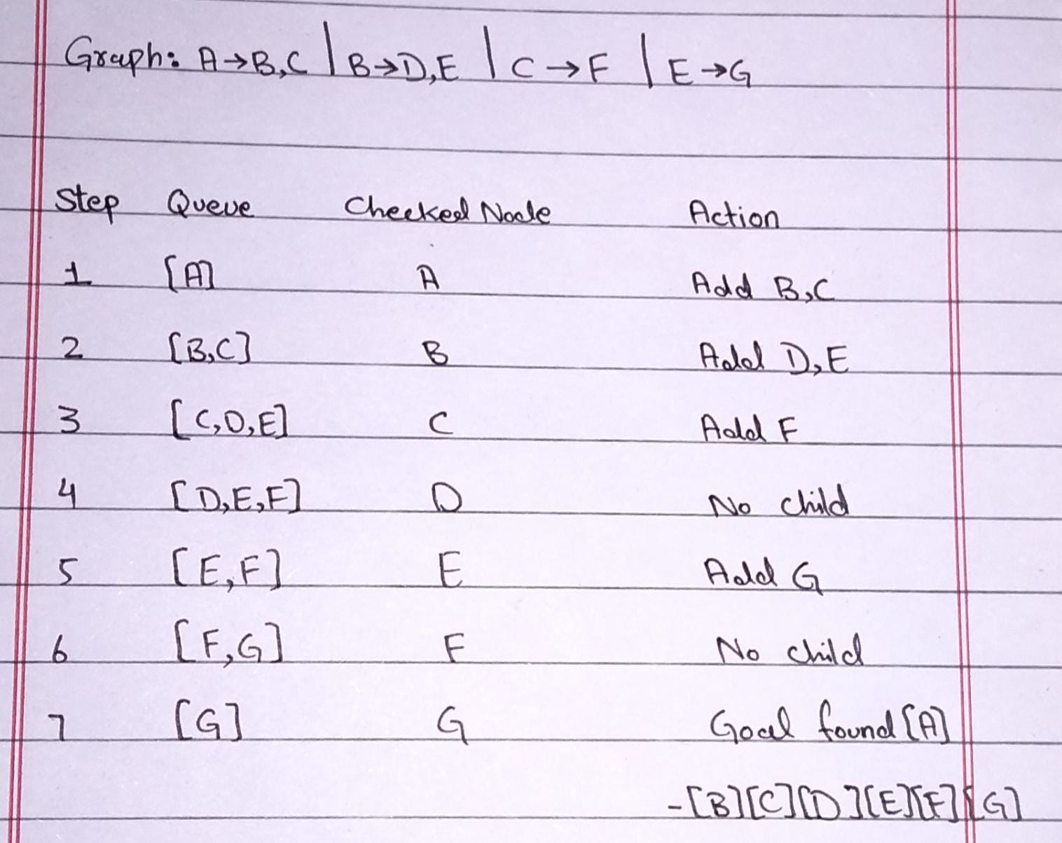
BFS Visit Order = A, B, C, D, E, F, G
BFS Final Path = A -> B -> E -> G
- DFS – Depth First Search:
DFS goes deep in one path. It uses Stack.
Stack Steps:
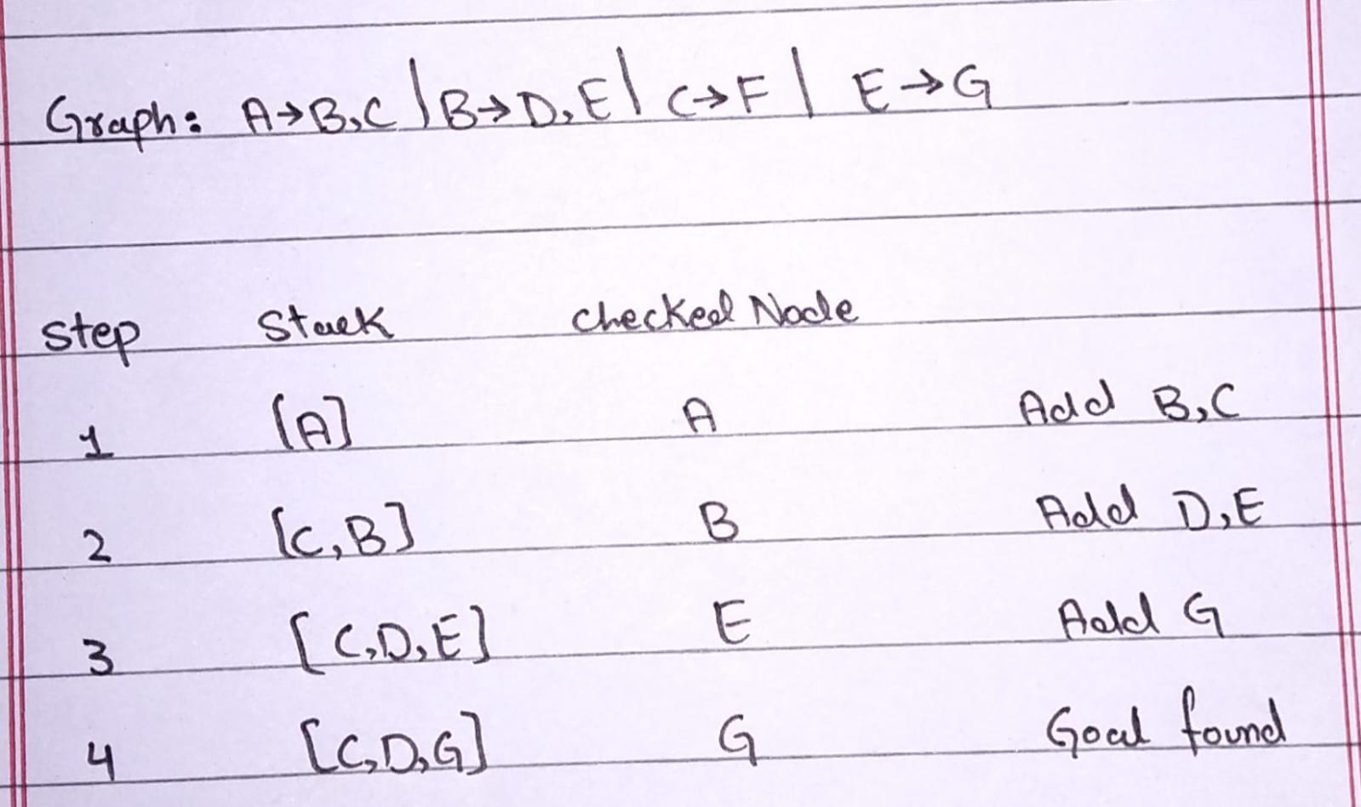
DFS Visit Order = A, B, E, G
DFS Final Path = A -> B -> E -> G

Verification: When we run the given BFS and DFS code, output is A,B,E,G which matches our manual trace. So our answer is correct.

Task-02:
Lab Report - Depth Limited Search (DLS)
- Introduction
In this lab I have implemented Depth Limited Search. With Depth Limited Search you don't search through the whole graph but only search up to a certain depth. I have tested the code with the same graph provided in the lab. I have set the root as A (depth 0) and tested the code with depths of 1, 2, 3 and 4.

- Graph
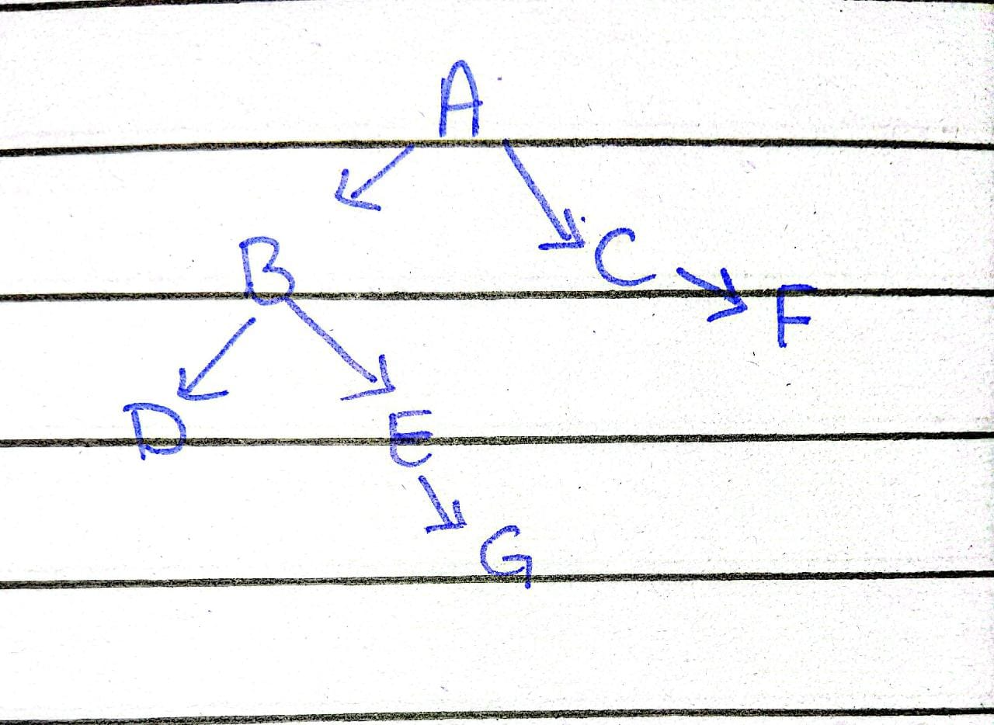

- Method
I created a function called run_dls_trace, which consists of:
- If the current node is the goal node then return FOUND.
- If the limit reaches 0 then return CUTOFF. This means there might be more nodes to look at but we have hit our limit.
- If none of the neighbors have been checked and we have not FOUND the goal then return FAILURE.
- I also included a cycle checker that checks for cycles locally within the path. If the neighbor is already in the current path then we won't expand it. This ensures the code doesn't go into a loop.
- Results
I ran the code through with the depths of 1, 2, 3 and 4. The results were:
- Depth 1: Status = CUTOFF, Path = None
- Depth 2: Status = CUTOFF, Path = None
- Depth 3: Status = FOUND, Path = ['A', 'B', 'E', 'G']
- Depth 4: Status = FOUND, Path = ['A', 'B', 'E', 'G']
With depth 1 we were only able to find B and C. With depth 2 we were able to find D, E, F but couldn't find G. However with depth 3 we FOUND the goal meaning the status was FOUND. With depth 4 we were still able to find the goal as the depth is higher than the depth of the goal so the status was FOUND.
- Conclusion
The Depth Limited Search is working correctly. If the depth is less than the depth of the goal node then the goal will not be FOUND, even though it does exist. This means we will get a CUTOFF rather than a FAILURE. CUTOFF means that the search was cut off due to the limit. Whereas FAILURE means the goal is completely absent from the graph. The cycle checker also ensures that the search is safe from loops.

